**SOURCE TWO** – Papyrus Script Detailing the final judgement and the feather of truth

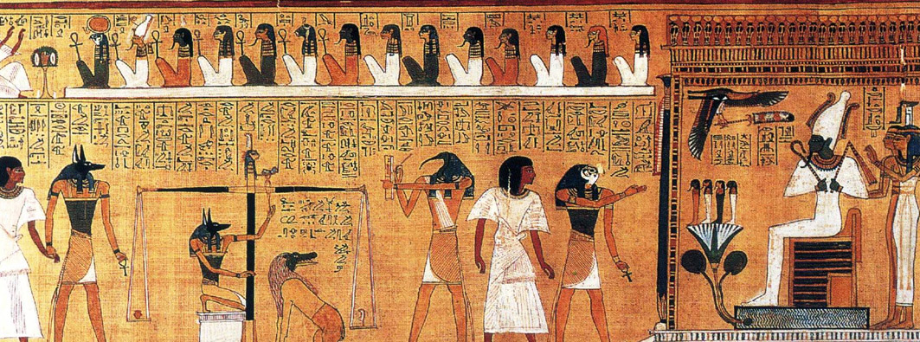

# The weighing of the heart ceremony, the judgment day of the ancient Egyptian religion. The heart of the deceased is weighed against the Feather of Ma'at, the goddess of truth and justice [86]. In the Papyrus of Ani circa 1200 BCE (public domain), via Wikimedia Commons.